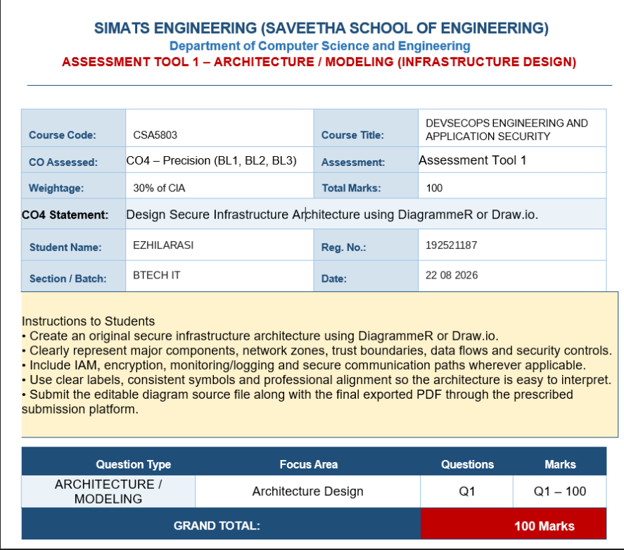

SECURE INFRASTRUCTURE ARCHITECTURE USING DEVSECOPS
Course Code: CSA5803 | Course: DevSecOps Engineering and Application Security

1. Problem Statement and Design Objective
Design an original secure infrastructure for a web-based application that exposes services to untrusted users while protecting application workloads, databases, secrets, logs and backups. The architecture must demonstrate clear network zones, trust boundaries, secure communication paths, identity and access management, encryption, monitoring/logging and DevSecOps controls.

2. Proposed Architecture
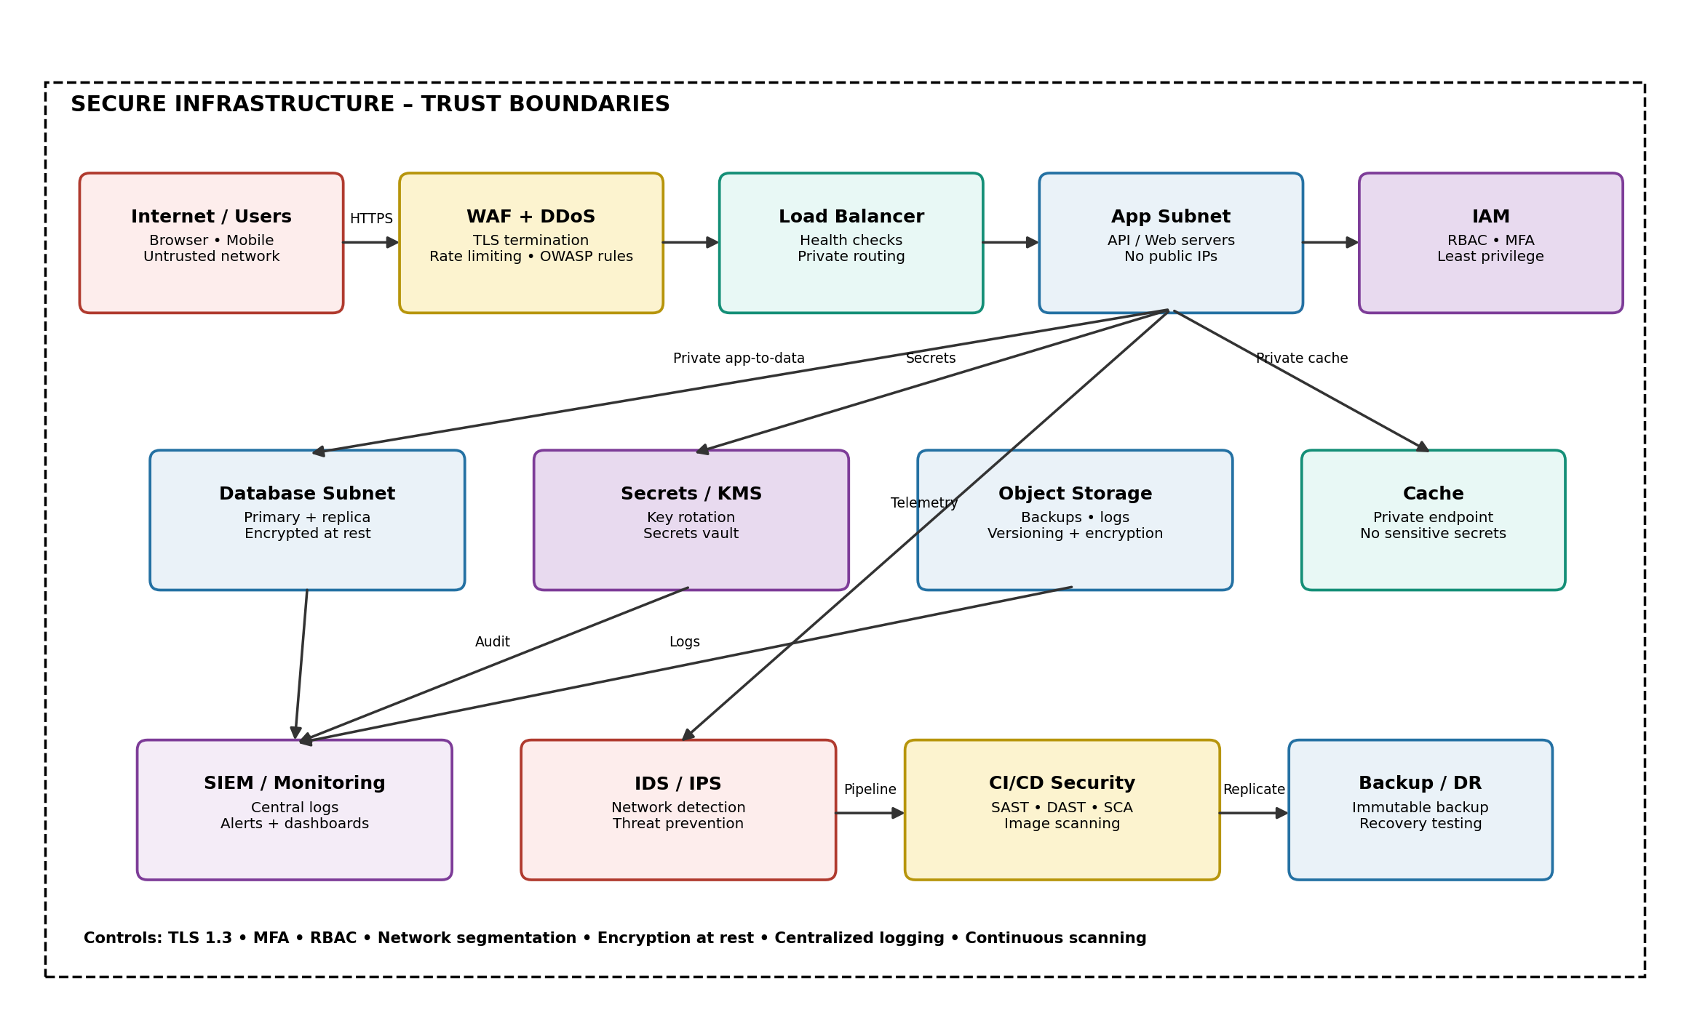
Figure 1. Secure 3-tier infrastructure with Zero Trust and DevSecOps security controls.
The proposed design separates the public edge, application workloads, protected data services and security operations. No application server or database is directly exposed to the Internet. Every sensitive request is authenticated, authorized, encrypted and logged.

3. Major Components and Their Roles
Component | Zone | Main Function | Security Controls
Internet / Users | Untrusted | Initiates HTTPS requests | TLS, browser security, MFA
WAF + DDoS Protection | Edge | Filters malicious traffic | OWASP rules, rate limiting, DDoS mitigation
Load Balancer | Edge/App boundary | Distributes traffic to healthy servers | TLS policy, health checks, private routing
Application Servers | Private App | Runs business logic and APIs | No public IP, hardened OS, least privilege
IAM | Identity | Manages users, roles and service identities | RBAC, MFA, short-lived credentials
Database | Private Data | Stores application data | Encryption, private subnet, backups, restricted ports
Secrets / KMS | Protected Security | Stores secrets and cryptographic keys | Key rotation, access policies, audit trail
Object Storage | Protected Data | Stores backups and logs | Encryption, versioning, immutable retention
SIEM / Monitoring | Security Ops | Aggregates logs and alerts | Central logging, correlation, anomaly detection
IDS / IPS | Security Ops | Detects/prevents network threats | Signature and behavior-based detection
CI/CD Security | DevSecOps | Secures build and deployment pipeline | SAST, DAST, SCA, image scanning
Backup / DR | Recovery | Restores service after failure | Immutable backups, recovery tests, RPO/RTO

4. Trust Boundaries and Network Segmentation
- Boundary 1 – Internet to Edge: all external traffic is considered untrusted. Only HTTPS is accepted.
- Boundary 2 – Edge to Application: WAF and load balancer validate/filter requests before they reach application servers.
- Boundary 3 – Application to Data: databases and caches are private and accept traffic only from approved application identities or security groups.
- Boundary 4 – Security Operations: logs are forwarded to a separate monitoring/SIEM zone so attackers cannot easily erase evidence from the workload.
- Boundary 5 – CI/CD to Production: deployment identities are restricted and production changes require authenticated, authorized pipeline actions.
Segmentation reduces lateral movement. A compromise of a public-facing component therefore does not automatically give an attacker direct access to the database, secrets or backup systems.

5. Data Flow and Secure Communication
- User sends an HTTPS request using TLS 1.2/1.3 to the public endpoint.
- WAF checks request signatures, rate limits, suspicious payloads and common web attacks.
- The load balancer routes only valid traffic to a healthy private application server.
- The application authenticates the user through IAM and applies role-based authorization before executing privileged operations.
- Application-to-database, application-to-cache and application-to-secrets traffic uses private network paths and encrypted channels where supported.
- Application and security events are forwarded to centralized monitoring/SIEM for detection, alerting and audit.
- Backups are encrypted and stored separately with retention/versioning and recovery testing.

6. IAM, Authentication and Authorization
- Use centralized Identity and Access Management with Role-Based Access Control (RBAC).
- Enforce Multi-Factor Authentication (MFA) for administrators and privileged users.
- Apply least privilege: users, services and pipelines receive only the permissions required for their tasks.
- Use separate identities for developers, CI/CD pipelines, application services and administrators.
- Prefer short-lived tokens/credentials over permanent access keys.
- Review privileged permissions periodically and disable unused accounts immediately.
- Record authentication, authorization failures, privilege changes and administrative actions in the audit log.

7. Encryption Strategy
Data State | Protection | Example Control
In Transit | TLS for external and internal sensitive communication | TLS 1.2/1.3, certificate validation
At Rest | Encrypt databases, storage, backups and logs | AES-256 or managed cloud encryption
Secrets | Never hard-code passwords/API keys in source code | Secrets vault + KMS
Keys | Separate key management from application data | KMS/HSM-backed keys, rotation and audit

8. Monitoring, Logging and Incident Detection
- Collect WAF, load balancer, application, IAM, database, operating-system and network security logs.
- Send logs to centralized SIEM with restricted write access and controlled retention.
- Create alerts for repeated failed logins, privilege escalation, unusual API activity, suspicious network connections and unexpected deployment changes.
- Synchronize system clocks so events can be correlated accurately.
- Protect logs against unauthorized modification and deletion.
- Use dashboards for availability, authentication failures, security alerts and deployment health.

9. DevSecOps Security in the CI/CD Pipeline
Stage | Security Check | Purpose | Gate
Code | SAST + secret scanning | Find insecure code and leaked credentials | Fail on critical findings
Dependencies | SCA / dependency audit | Detect vulnerable libraries | Block critical CVEs
Build | Container/image scanning | Find vulnerable packages/configurations | Block unsafe images
Test | DAST / API security tests | Find runtime web weaknesses | Fail critical vulnerabilities
Deploy | IaC validation + approvals | Prevent insecure infrastructure changes | Policy + approval gate
Operate | Runtime monitoring | Detect attacks and drift | Alert + incident response

10. Availability, Backup and Disaster Recovery
- Deploy more than one application instance so a single server failure does not stop the service.
- Use health checks and load balancing to remove unhealthy instances.
- Maintain encrypted backups separate from the primary database environment.
- Use versioning/immutability for critical backups to reduce ransomware impact.
- Define Recovery Point Objective (RPO) and Recovery Time Objective (RTO) according to business requirements.
- Perform periodic restore tests instead of assuming that a successful backup automatically means successful recovery.

11. Threats and Mitigations
Threat | Risk | Mitigation
SQL Injection | Unauthorized data access | Parameterized queries, WAF, SAST/DAST
Credential Theft | Account takeover | MFA, RBAC, short-lived tokens, monitoring
DDoS | Service unavailability | DDoS protection, rate limiting, scalable edge
Ransomware | Data/service loss | Segmentation, EDR/monitoring, immutable backups
Secret Leakage | Unauthorized system access | Secret scanning, vault, key rotation
Lateral Movement | Expansion after compromise | Private subnets, least privilege, network policies
Supply-chain Attack | Compromised dependency/image | SCA, signed artifacts, image scanning
Log Tampering | Loss of forensic evidence | Centralized restricted SIEM logging

12. Why This Architecture Is Secure
- Defense in depth: multiple independent controls protect each critical layer.
- Zero Trust principle: network location alone does not grant trust; identity, device/service context and authorization are checked.
- Least privilege limits the impact of compromised accounts and services.
- Segmentation prevents direct Internet-to-database access and restricts lateral movement.
- Encryption protects data while moving and while stored.
- Continuous monitoring provides early detection and supports incident investigation.
- DevSecOps moves security checks into development and deployment rather than waiting until production.

13. Conclusion
The proposed secure infrastructure satisfies the assessment requirements by clearly modeling major components, network zones, trust boundaries, data flows and security controls. The design combines secure networking, IAM, encryption, monitoring, backup/recovery and automated DevSecOps security checks. It is therefore suitable as an original architecture model for a production-oriented web application and can be reproduced in DiagrammeR or Draw.io.

14. Draw.io / DiagrammeR Implementation Guide
- Create four horizontal zones: Internet/Edge, Application, Data, and Security Operations.
- Use rounded rectangles for components and dashed rectangles for trust boundaries.
- Connect components with directional arrows and label important paths such as HTTPS, private API-to-DB and telemetry.
- Add security icons/labels for WAF, IAM, KMS, SIEM, IDS/IPS and backup/DR.
- Use consistent colors for zones, but retain readable black labels and professional alignment.
- Export the final diagram as PDF and retain the editable .drawio or DiagrammeR source file as required by the assessment.

